Supplement Facts
Serving Size: | 1 Chew
Servings Per Container: |  | 60
Amount per Serving
Calories Total | 20
from Fat | 5
 |  | % Daily Value⁺
Total Fat | 0.5 g | 1%
Sodium | 10 mg | <1%
Total Carbohydrate | 4 g | 1%
Sugars | 3 g
 |  | % Daily Value
Vitamin D | 100 IU | 25%
Vitamin K | 40 mcg | 50%
Calcium | 500 mg | 50%
<TD* Daily Value not established.
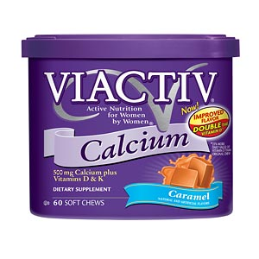

+ Percent Daily Values are based on a 2,000 calorie diet. Your daily values may be higher or lower depending on your calorie needs.
Online drugstore price $8.39

Corn Syrup, Calcium Carbonate, Sugar, Nonfat Milk, Butter, Partially Hydrogenated Vegetable Oil (soybean and cottonseed), Soy Lecithin, Natural & Artificial Flavor, Glyceryl Monostearate, Carrageenan, Sodium Citrate, Sodium Phosphate, Vitamin D3, Vitamin K1

Supplement Facts
Serving Size: | 1 Caplet
Servings Per Container: |  | 110
Amount per Serving |  | % Daily Value
Vitamin D | 200 IU | 50%
Vitamin K | 40 mcg | 50%
Calcium | 500 mg | 50%
<TD* Daily Value not established.

Online drugstore price $12.99
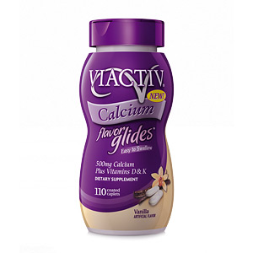
Cellulose, Croscarmellose Sodium, Maltodextrin, Acacia, Polyvinyl Alcohol, Titanium Dioxide, Polyethylene Glycol, Talc, Sodium Carboxy Methyl Cellulose, Dextrin, Glucose, Magnesium Stearate, Corn Starch, Artificial Vanilla cream flavor, Dextrose, Lecithin, Sucralose, Sodium Citrate, Phytonadione, Tricalcium Phosphate, Cholecalciferol

***This product is not available currently****
Nutrition Facts
Serving Size: | 1 Tablet
Servings Per Container: |  | 120
Amount per Serving |  | % Daily Value
Vitamin D | 400 IU
Calcium | 600 mg | 60%
<TD* Daily Value not established.

Online drugstore price $12.99
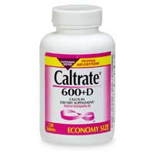

Calcium Carbonate, Maltodextrin, Cellulose, Mineral Oil, Hydroxypropyl Methylcellulose, Titanium Dioxide, Polysorbate 80, Gelatin, Sucrose, Polyethylene Glycol 8000, Corn Starch, Magnesium Stearate, Vegetable Oil, FD&C Yellow 6 Lake, Stearic Acid, Crospovidone, Vitamin D, Dl Alpha Tocopherol

Nutrition Facts
Serving Size: | 1 Tablet
Servings Per Container: |  | 90
Amount per Serving |  | % Daily Value
Vitamin D | 200 IU | 50%
Calcium | 600 mg | 60%
Magnesium | 40 mg | 10%
Zinc | 7.5 mg | 50%
Copper | 1 mg | 50%
Manganese | 1.8 mg | 90%
Boron | 250 mcg | *
<TD* Daily Value not established.
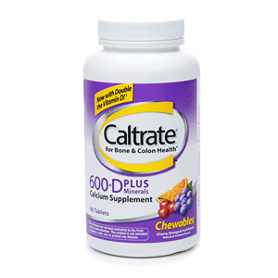
Dextrose, Calcium Carbonate, Maltodextrin, Natural & Artificial Flavors, Magnesium Stearate, Magnesium Oxide, Adipic Acid, Cellulose, Mineral Oil, Zinc Oxide, FD&C Red 40 Lake, FD&C Yellow 6 Lake, Manganese Sulfate, FD&C Blue 2 Lake, Gelatin, Sucrose, Cupric Oxide, Corn Starch, Sodium Borate, Vegetable Oil, Stearic Acid, Crospovidone, Hydroxypropyl Methylcellulose, Vitamin D, Dl Alpha Tocopherol
Online drugstore price $9.99

Supplement Facts
Serving Size: | 1 Tablet
Servings Per Container: |  | 120
Amount per Serving
Calories Total | 0
 |  | % Daily Value
Vitamin D | 400 IU | 100%
Calcium | 500 mg | 50%
<TD* Daily Value not established.

Online drugstore price $15.59
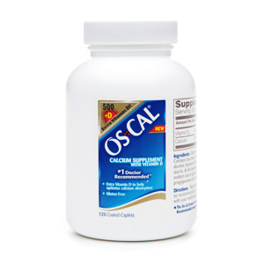
Calcium Carbonate, Corn Syrup Solids, Talc, Contains Less Than 2% of Polysorbate 80, Polyvinyl Alcohol, Titanium Dioxide, Polyethylene Glycol 3350, Corn Starch, D Alpha Tocopherol, Cholecalciferol (Vitamin D3), sodium starch glycolate, Sucrose, Gelatin, Calcium Stearate, Propylparaben and Methylparaben (Preservatives)

Supplement Facts
Serving Size: | 1 Tablet
Servings Per Container: |  | 120
Amount per Serving
Calories Total | 0
 |  | % Daily Value
Vitamin D | 400 IU | 100%
Calcium | 500 mg | 50%
<TD* Daily Value not established.

Online drugstore price $15.19
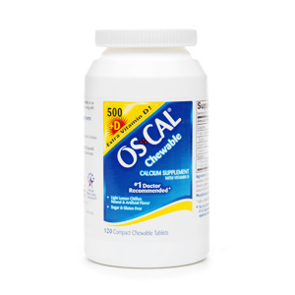
Calcium Carbonate, Sorbitol, Isomalt, Povidone, Contains Less Than 1% of Magnesium Stearate, Gelatin, Sucrose, Aspartame, Corn Starch, Natural and Artificial Flavor, Cholecalciferol (Vitamin D3)

Nutrition Facts
Serving Size: | 2 tablets
Servings Per Container: |  | 80
Amount per Serving
Calories Total | 10
 |  | % Daily Value⁺
Sodium | 10 mg | < 1
Sugars | 3 g
 |  | % Daily Value
Calcium | 800 mg | 80

<TD* Daily Value not established.
+ Percent Daily Values are based on a 2,000 calorie diet. Your daily values may be higher or lower depending on your calorie needs.

Online drugstore price $8.99
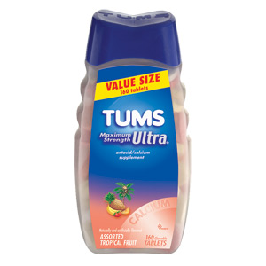

Active Ingredients: Calcium Carbonate USP Grade (1000 mg per tablet)
Inactive Ingredients: Sucrose, Starch, Talc, Mineral Oil, Natural & Artificial Flavor, Sodium Polyphosphate, Yellow 6 Lake, FD&C Yellow 5 Lake, Red 40 Lake, Blue 1 Lake

Supplement Facts
Serving Size: | 2 Capsules
Servings Per Container: |  | 60
Amount per Serving |  | % Daily Value
Vitamin C | 5 mg | 8%
Vitamin D | 400 IU | 100%
Calcium From 1000mg coral calcium | 370 mg | 37%
Magnesium | 56 mg | 14%
<TD* Daily Value not established.

Online drugstore price $9.99
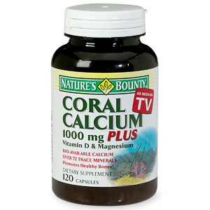
Our Coral Calcium is mined, not collected, from an above ground source located in Okinawa, Japan, making it Earth Friendly. *This product contains 185mg of elemental Calcium per capsule counted towards your daily Calcium needs.** These statements have not been evaluated by the Food and Drug Administration. This product is not intended to diagnose, treat, cure or prevent any disease.

Supplement Facts
Serving Size: | 2 Caplets
Servings Per Container:
Amount per Serving |  | % Daily Value
Calcium as Ultradense calcium citrate | 630 mg | 63
Vitamin D3 as cholecalciferol 100% | 400 IU*
<TD* Daily Value not established.

Online drugstore price $12.99

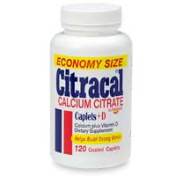
Calcium Citrate, Polyethylene Glycol, Croscarmellose Sodium, HPMC, Color Added, Magnesium Silicate, Magnesium Stearate, Vitamin D3

Supplement Facts
Serving Size: | 1 piece
Servings Per Container: |  | 30
Amount per Serving
Calories Total | 35
from Fat | 15
 |  | % Daily Value⁺
Total Fat | 1.5 g | 2%
Saturated Fat | 1 g | 4%
Cholesterol | 5 mg | 1%
Sodium | 40 mg | 2%
Total Carbohydrate | 5 g | 2%
Dietary fiber | 0 g | 0%
Sugars | 4 g
Protein | 0 g
 |  | % Daily Value
Vitamin A | IU | 0%
Vitamin C | mg | 0%
Vitamin D as cholecalciferol | 200 IU | 50%
Calcium as calcium citrate, USP | 500 mg | 50%

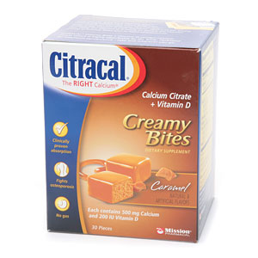

<TD* Daily Value not established.
+ Percent Daily Values are based on a 2,000 calorie diet. Your daily values may be higher or lower depending on your calorie needs.

Online drugstore price $7.49
Sugar, Calcium Citrate, Enriched Bleached Wheat Flour, EGF, Soybean Oil, Partially Hydrogenated Palm Kernel and Palm Oils (contains no trans fat), Nonfat Dry Milk, Corn Syrup, Natural and Artificial Flavors, Vitamin D (contains 2% or less), Water, Cornstarch, Xantham Gum, Glycerol, Whey, Soy Lecithin, Potassium Sorbate (a Preservative), Caramel Color , Salt, Yellow 5 & 6 Lake, Blue 2 Lake, Red 40 Lake

Supplement Facts
Serving Size: | 2 gummies
Servings Per Container: |  | 30
Amount per Serving
Calories Total | 30
Amount per Serving |  | % Daily Value⁺
Sodium | 55 mg | 2%
Total Carbohydrate | 7 g | 2%
Sugars | 7 g
 |  | % Daily Value
Vitamin D (as cholecalciferol) | 500 IU | 125%
Calcium (elemental) | 500 mg | 50%
Phosphorus | 230 mg | 23%
<td* Daily Value not established.</td

+ Percent Daily Values are based on a 2,000 calorie diet. Your daily values may be higher or lower depending on your calorie needs.

Corn Syrup, Sucrose, Tricalcium Phophate, Water, Sodium Citrate, Citric Acid, Pectin, Maqui Berry Juice Concentrate (Color), Artificial Flavor, FD&C Yellow 6 Aluminum Lake, FD&C Red 40 (CI 16035), Vitamin D3 (Cholecalciferol). Online drugstore price $12.99
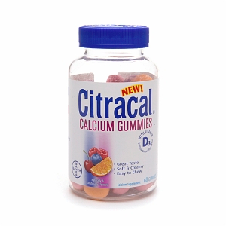

Supplement Facts
Serving Size: | 2 Gummy Bites
Servings Per Container: |  | 25
Amount per Serving
Calories Total | 35
Amount per Serving |  | % Daily Value⁺
Sodium | 22 mg | 1
Total Carbohydrate | 9 g | 3+
Sugars | 7 g
 |  | % Daily Value
Vitamin D Vitamin D3 | 800 IU | 200
Calcium | 500 mg | 50
Phosphorus | 230 mg | 23
<td* Daily Value not established.</td

+ Percent Daily Values are based on a 2,000 calorie diet. Your daily values may be higher or lower depending on your calorie needs.

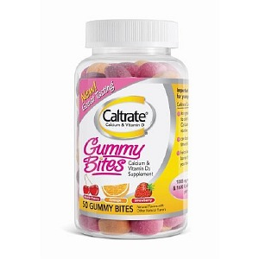

Corn Syrup, Sucrose, Tribasic Calcium Phosphate, Water, Contains Less Than 2% of:, Annatto Seed Extract (Color), Black Carrot Juice Concentrate (Color), Cholecalciferol (Vitamin D3), Citric Acid, Ethyl Alcohol, Glycerin, Invert Sugar, Medium Chain Triglyceride, Natural Flavors, Pectin, Polysorbate 80, Potassium Hydroxide, Propylene Glycol, Sodium Citrate, Tocopherols (to retard oxidation), May also contain less than 2% of: (to retard oxidation), Acacia, Corn Starch, Modified Corn Starch, Silicon Dioxide, Sodium Ascorbate (to retard oxidation)
Online drugstore price $9.99

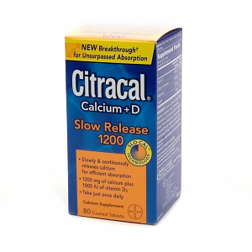
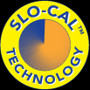
Supplement Facts
Serving Size: | 2 Tablets
Servings Per Container: |  | 40
 |  | % Daily Value⁺
Sodium | 5 mg | <1%
 |  | % Daily Value
Vitamin D | 1000 IU | 250%
Calcium (elemental) | 1200 mg | 120%
Magnesium | 80 mg | 20%
<td* Daily Value not established.</td

+ Percent Daily Values are based on a 2,000 calorie diet. Your daily values may be higher or lower depending on your calorie needs.

Calcium Carbonate, Calcium Citrate, Magnesium Hydroxide, Acacia Gum (Acacia Senegal), Hydroxypropyl Methycellulose, Croscarmellose Sodium, Magnesium Silicate, Titanium Dioxide, Propylene Glycol, Discaprylate/Dicaprate, Magnesium Stearate, Inulin, Oligofructose, Vitamin D3 (Cholecalciferol)
Online drugstore price $13.99

