



2025 Walmart Community Pharmacy Scholarship for Pharmacy Students

Program Information and Application Instructions

Last updated: 5/21/2025

Deadline: July 7, 2025 at 11:59 p.m. Hawaii Time (HT)

Table of Contents
THE PROGRAM 3
Description 3
Goal of the Program 3
Eligibility Requirements 3
Scholarship Notification 4
Scholarships Payments 4
Scholarships Questions 4
APPLICATION INSTRUCTIONS 4
APPLICATION DEADLINE 4
APPLICATION BASICS 4
APPLICATION SECTIONS 5
Step 1: Applicant Information 5
Step 3: GPA Verification Upload 6
Step 4: Resume Upload 8
Step 5: Essay 8
Step 6: Letters of Reference Error! Bookmark not defined.
Step 7: Applicant Certification 9
APPLICATION REVIEW 11
Review Overview 11
Review Criteria 11
1) Resume 11
2) Essay 12
3) Recommendation letters 12

THE PROGRAM

Description
The Walmart Community Pharmacy Scholarship for Pharmacy Students will be awarded to seven (7) outstanding Doctor of Pharmacy (Pharm.D.) degree students who are accepted or enrolled in the professional curriculum at a U.S. college or school of pharmacy. Selected awardees must demonstrate leadership, academic success, and a commitment to serving rural or medically underserved patient populations. Each awardee will receive a single $5,000 scholarship.

Goal of the Program
The American Association of Colleges of Pharmacy (AACP) and Walmart are committed to promoting education and healthcare access to improve health for all. The scholarship will support the financial need of students enrolled in Doctor of Pharmacy (Pharm.D.) degree programs who plan to serve in rural areas, medically underserved areas or populations (MUA/Ps), or Health Professional Shortage Areas (HPSAs) upon graduation. The goal of the scholarship program is to promote and support student pharmacists who will address health disparities.

Eligibility Requirements
Qualified applicants must meet the following requirements:
- Eligible student statuses during the 2025-26 Program:
  - Accepted into a professional Pharm.D. program for the 2025 entering class (i.e. P1 student during the 2025-26 academic year)
  - Enrolled as a P2 or P3 Pharm.D. student in a 4-year program
  - Enrolled as a P2 Pharm.D. student in an accelerated 3-year program
  - Enrolled as a P3 through P5 (out of P6) student in a 0-6/7 program
- Students must demonstrate leadership, academic success, and a commitment to serving rural, medically underserved areas or populations (MUA/Ps), or Health Professional Shortage Areas (HPSAs) upon graduation from a Pharm.D. degree program.
- Only US citizens and permanent US residents are eligible.
- Students must be in good standing (minimum 2.5 GPA on a 4.0 scale) at their current (or most recent) institution at the time of application. Applicants from schools with other grading systems are still eligible to apply for the scholarship.
- Students must submit a completed application by the deadline.
- If a scholarship is awarded to an accepted (not yet enrolled) pharmacy student, the award will be granted to the institution after the individual has started classes in the Pharm.D. program.
- Awardees will be ineligible to apply for this scholarship again in the future.
- Students who will graduate from a Pharm.D. program in 2025 are NOT eligible for the scholarship.
- Commitment to practice in community pharmacy with evidence of previous work or volunteerism in community practice.

Scholarship Notification

- Completed applications are due July 7, 2025, at 11:59 p.m. Hawaii Time (HT)
- Completed applications will be reviewed by September 2025.
- Scholarship recipients will be notified during Fall 2025.
- Funds will be forwarded to the student’s institution during Fall 2025.
- AACP will announce the scholarship recipients on the AACP and Pharmacy Is Right for Me websites and social media during Fall 2025.
- Walmart may also release related announcements about the scholarship recipients via the company’s communication channels.

Scholarships Payments
A single scholarship in the amount of $5,000 each will be awarded to each scholarship recipient. AACP will pay the scholarship funds for each awardee directly to the pharmacy college or school where the student is enrolled. Funds will be dispersed during Fall 2025 after the awardee’s initial or ongoing enrollment in a Pharm.D. program at the college or school of pharmacy is confirmed. Each institution will exclusively apply scholarship funds to the awardee’s tuition and/or fees. An applicant may receive this scholarship only once.

Scholarships Questions
Please contact AACP at walmart@aacp.org with questions.

APPLICATION INSTRUCTIONS

APPLICATION DEADLINE

Applications are due July 7, 2025, at 11:59 p.m. Hawaii Time (HT).

APPLICATION BASICS

- Access the scholarship application online at: https://my.reviewr.com/site/walmartscholarship2025
- Review the eligibility criteria under the “RULES” heading to ensure you are eligible for this scholarship.
- Select the "CREATE AN ACCOUNT” to begin a new application.
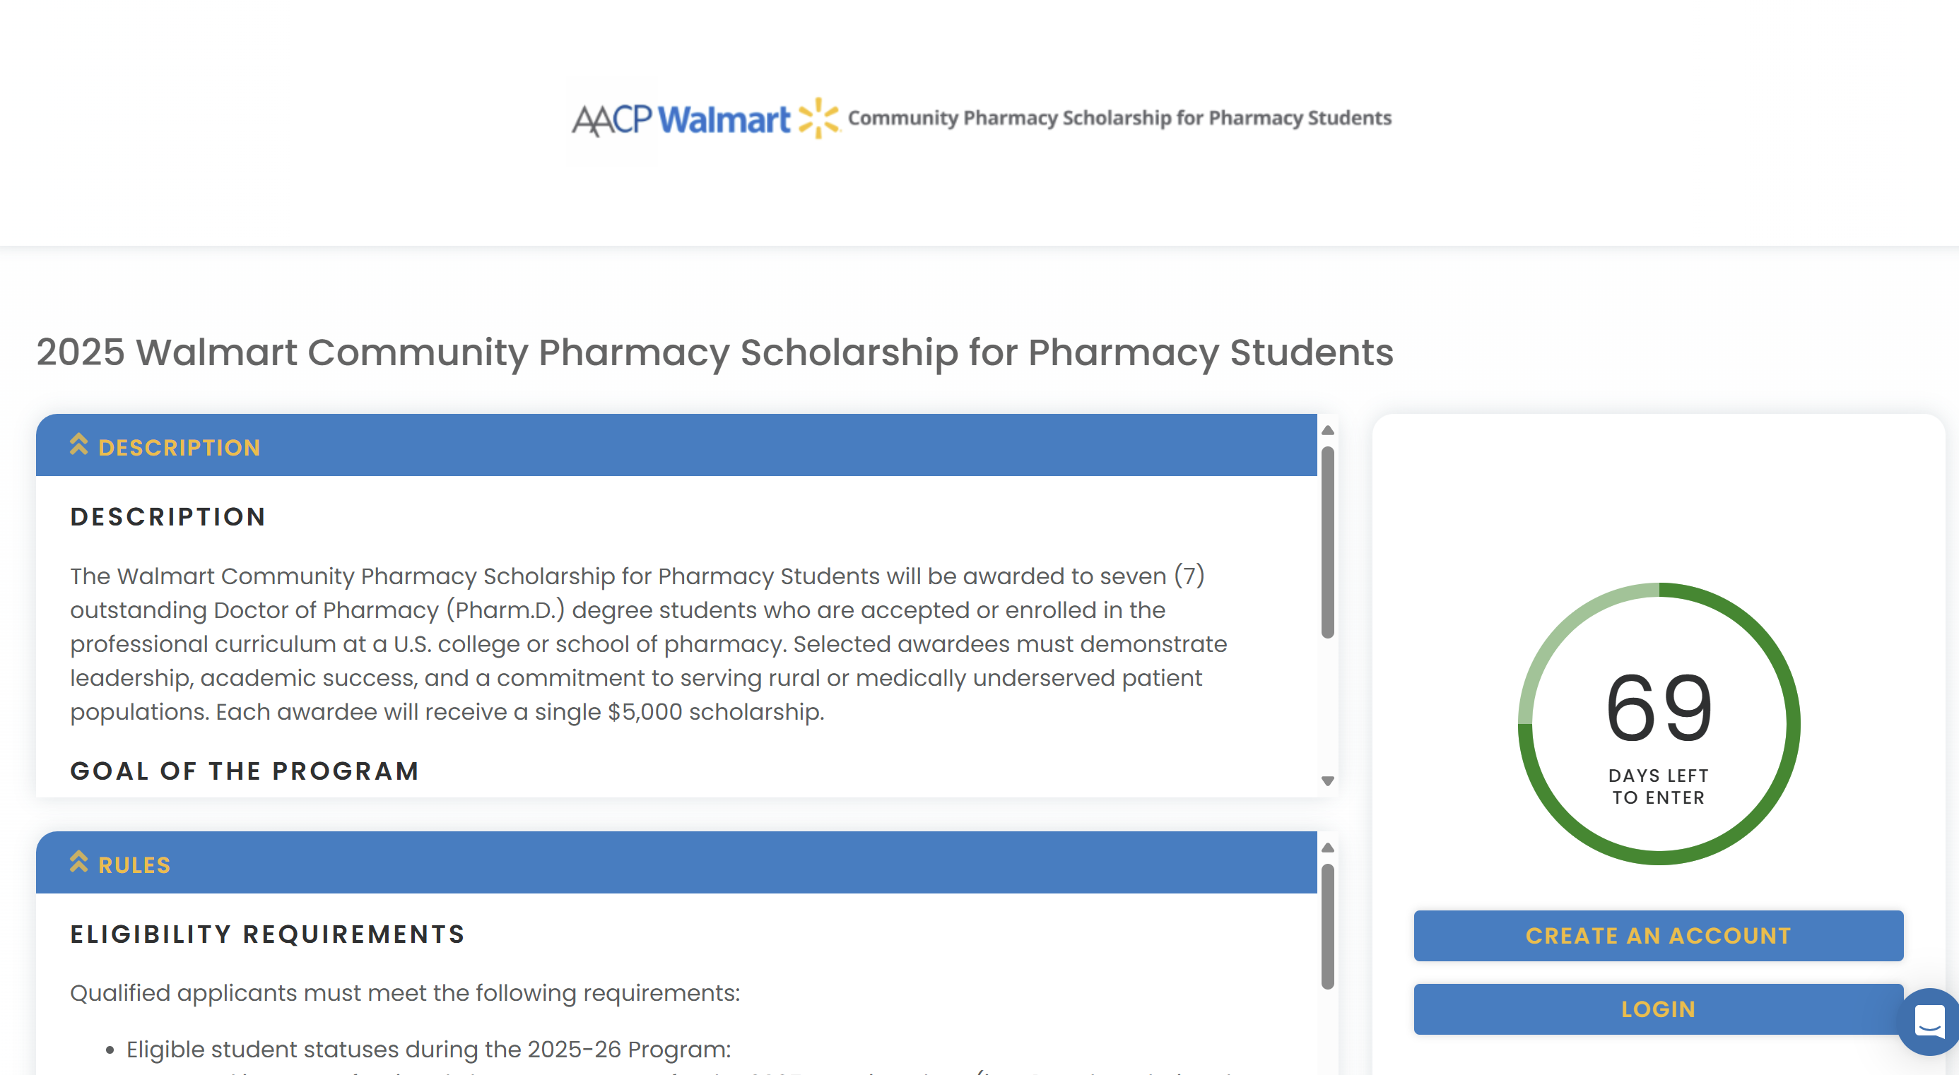

APPLICATION SECTIONS

Step 1: Applicant Information
- Name
- Current Street Address (this information will not be visible to reviewers)
- Email (this information will not be visible to reviewers)
- Preferred Phone Number (this information will not be visible to reviewers)
- College or School of Pharmacy
  - If you are currently an applicant and have not yet decided where you will enroll, please choose "Undecided.” See also the “Scholarship Payment” section for enrollment requirements.
- Walmart Work History (this information will not be visible to reviewers)
  - Have you ever worked, or do you currently work, at Walmart in any capacity (including pharmacy or other departments)? This question is for reporting purposes only and does not impact scholarship eligibility or selection.
    - Yes, currently employed at Walmart
    - Yes, previously employed at Walmart
    - No, never employed at Walmart

Step 2: Eligibility Information
- Academic Status (this information will not be visible to reviewers)
  - Eligible student statuses during the 2025-2026 Academic Year:
    - Accepted into a professional Pharm.D. program for the 2025 entering class
    - Enrolled as a P2 or P3 Pharm.D. student in a 4-year program,
    - Enrolled as a P2 Pharm.D. student in an accelerated 3-year program, OR
    - Enrolled as a P3 through P5 (out of P6) student in a 0-6/7 program.
- GPA for Undergraduate or Pharm.D. Program to Date (this information will not be visible to reviewers)
  - Enter your GPA for your current degree program (undergraduate or Pharm.D). To be eligible for consideration, GPA must be 2.5 or greater on a 4.0 scale. Please enter "N/A" if your school uses a grading scale besides 4.0 (i.e., Pass/Fail).
  - Applicants from schools with other grading systems are still eligible to apply for the scholarship. Please email walmart@aacp.org, if you have additional questions regarding other grading systems.
- Residency (this information will not be visible to reviewers)
  - Only US citizens and permanent US residents are eligible.

Service to underserved patients in a community practice

Which of the following best describes your experience serving in underserved patients in community practice?
    - I have actively volunteered or worked in underserved communities for more than 100 hours.
    - I have volunteered or worked in underserved communities for less than 100 hours.
    - I have not volunteered or worked in underserved communities, but I am interested in doing so in the future.
    - None of the above applies to me.

Step 3: Letters of Reference
Two reference letters are required for the scholarship application. Each reference should be able to describe your attributes, (1) how you will contribute to a successful career in pharmacy and (2) your interest or commitment to serving as a community pharmacist to address health disparities. .
Contact each reference in advance, so they know to expect an email from this program.
- Reference #1: Faculty Member
  - Invite a faculty member to submit a recommendation on your behalf who can describe your attributes, how you will contribute to a successful career in pharmacy, and your interest or commitment to addressing health disparities.
  - Recommendations from faculty in undergraduate (community college and four-year institution), graduate, Pharm.D., and other professional programs are accepted.
  - Recommendations from non-teaching faculty and academic advisors are also acceptable.
- Reference #2:
  - Invite a second recommender who can describe your attributes, how you will contribute to a successful career in pharmacy, and your interest or commitment to addressing health disparities.
  - Acceptable recommenders include pharmacists, other healthcare providers, employers, supervisors, faculty, staff, mentors, advisors, or colleagues in educational, volunteer, or paid settings.

How to add a reference:
- Click “ADD NEW”
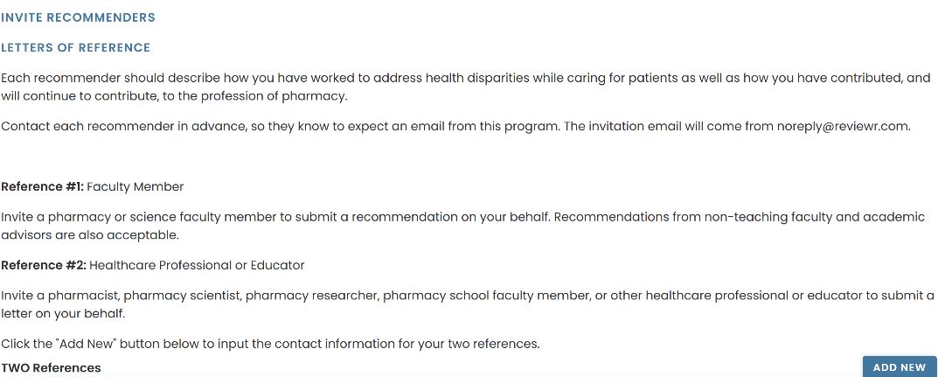
- Enter the reference’s first name, last name, and email address. Do not enter anything for “Supplemental Form Type” as it is already set to default to “Reference for Walmart Community…”

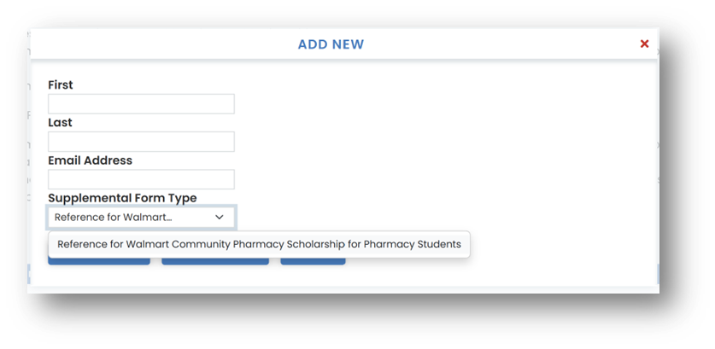

- Click “SAVE AND SEND” to trigger the invitation email to be sent to your reference.

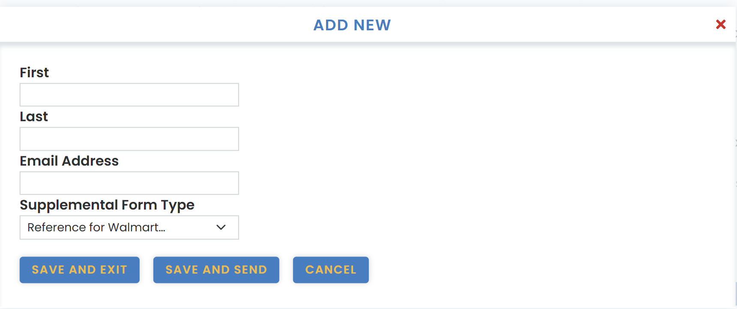
- The reference’s name will now appear, and their status will read “New”.
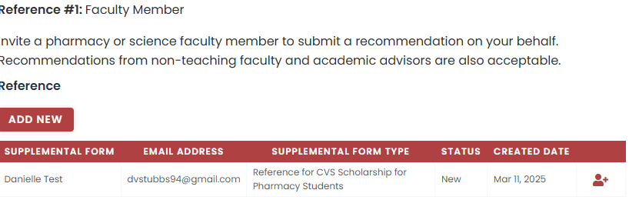
- The email invitation will come from noreply@reviewr.com, and we encourage you to advise your references to add that email to their safe sender list.
- Once your reference has submitted their letter, their status will change to “Ready”.
- We recommend you reach out to your recommenders to ensure that they receive the invitation email. If you need to resend the invitation, click on the “person+” icon on the right.

- If your references do not receive the email, they should contact us at walmart@aacp.org
- Your application will be considered incomplete until the references are submitted. Applications, including references, must be complete and submitted by the deadline to be considered.
- If you wish to delete a reference you added, you must contact AACP staff at walmart@aacp.org and we will delete it on your behalf.

Step 4: GPA Verification Upload
Upload an unofficial copy of your most recent transcript as a single PDF. To be eligible for consideration, GPA must be 2.5 or greater on a 4.0 scale. Your unofficial transcript will only be used to determine eligibility and not otherwise considered in the review process.

Applicants from schools with other grading systems are still eligible to apply for the scholarship. If you attend an institution with a non-standard grading system, upload a PDF copy of your transcript with the grading system description included. The grading system can usually be found on the back of the transcript.

Please email walmart@aacp.org, if you have additional questions regarding the academic standing verification process.

Step 5: Resume Upload
Your resume is a very important part of your scholarship application. It will be used to help differentiate your application from others and allow you to showcase your academic, extracurricular, and employment experiences, including those in support of rural areas, MUA/Ps, and/or HPSAs. Review the requirements below before you upload your resume.
- Save and submit your resume as a PDF.
- If you use any acronyms, also provide the full name.
- Use headers and/or section titles to organize your resume.
- Briefly describe any leadership roles and/or involvement.
- Include length of time spent at each organization and in each leadership role.

Step 6: Activities and Leadership
This section is an opportunity to expand upon your resume and/or include additional activities. It will be used to help differentiate your application from others and allow you to showcase your academic and extracurricular involvement. Be sure to include experiences, achievements, extracurricular activities, leadership roles and/or involvement as well as length of time spent in organizations and/or leadership roles.

Leadership Activities:
- Describe your activities and leadership in academic, collegiate, or university sponsored organization, club, research or activity
- Describe your activities and leadership in non-academic related environments (for example volunteering, work, civic groups)
- Be sure to include experiences, achievements, extracurricular activities, leadership roles and/or involvement as well as length of time spent in organizations and/or leadership roles.

Step 7: Essay
You are strongly encouraged to compose your essay in a separate word processor, then copy and paste as plain text into the text box. Use line breaks (the return key) to separate paragraphs. Please do NOT insert hyperlinks or other formatting. Limit essay to 6000 characters. Although you may utilize mentors, peers, advisors, and/or artificial intelligence (AI) tools or other online resources for proofreading or editing, your final submission must be a true reflection of your own work and must represent your individual ideas, thoughts, and experiences.

Describe how your life experiences influenced your decision to pursue a pharmacy career, with a particular focus on community pharmacy and its role in serving rural areas, medically underserved populations (MUA/Ps), or Health Professional Shortage Areas (HPSAs). Highlight any key volunteer, extracurricular, employment, or academic experiences that shaped your commitment to these communities and demonstrate your dedication to improving access to care. Explain how you envision using your role as a community pharmacist to address health disparities and make a meaningful impact in these settings.

Step 8: Applicant Certification
Your certification of this statement serves the same purpose as a legal signature.

Please read and sign below.

By adding my name to the text box below, I certify that all the information and statements I have provided in this application are current, correct, and complete to the best of my knowledge. I certify that all writing submitted by me as a part of this application is my own. This includes, but is not limited to, any personal essays or written responses. Although I may utilize mentors, peers, advisors, and/or artificial intelligence (AI) tools or other online resources for proofreading or editing, my final submission is a true reflection of my own work and represents my individual ideas, thoughts, and experiences.

I understand my certification of this statement serves the same purpose as a legal signature.
- Check “I certify”.
- A text box will appear. Add your full name to the text box to indicate your agreement.
- If you are ready to submit your completed application, click “Submit”.

I consent to sharing my name, email, pharmacy school, graduation year, and resume with Walmart to receive information about career opportunities and programs.
- I agree to share my information
- I do not agree to share my information

**Please note that you are not required to agree to sharing your information with Walmart. Not agreeing to share your information will not impact your application.

EDITING YOUR APPLICATION

Editing AFTER Submitting

If you need to edit your application after you have submitted it, you can do so by logging back in at https://my.reviewr.com/site/walmartscholarship2025 and clicking on the blue “EDIT” button on the top right corner. Please note that you can only edit your application until the deadline. After the deadline has passed, no more edits can be made. No exceptions.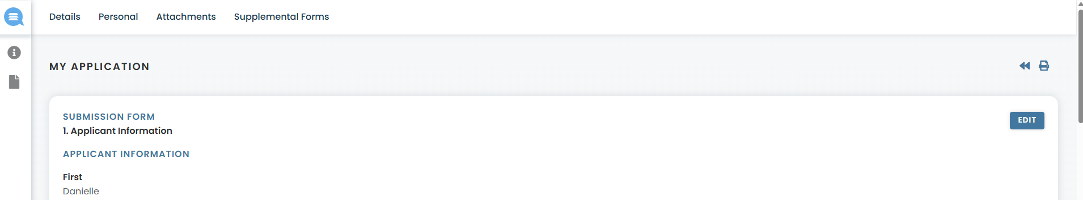
Checking Status of References

You can submit your application even if your references have not submitted their recommendation letters. To check the status of your references after submitting your application, log in and click on “Supplemental Forms” at the top. You can also resend invitation emails from here by clicking on the “person +” icon next to the reference’s name.

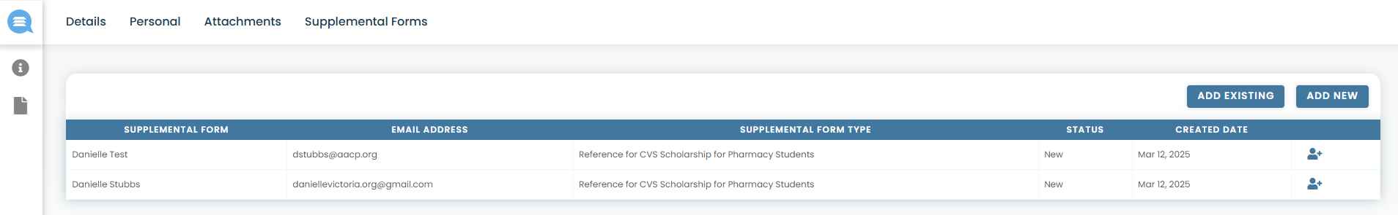
Status Meanings

- “New”: Reference has not yet logged in to begin submitting their letter.
- "Incomplete”: Reference has logged in to the platform but not yet submitted their letter.
- “Ready”: Reference has successfully submitted their letter and the reference is complete.

Adding Additional References/ Replacing References/ Deleting References

- You can add additional references under “Supplemental Forms” by clicking on “ADD NEW”, but please note only TWO (2) are required and only the first TWO (2) will be reviewed.

- If you wish to replace one reference with another, please contact the AACP staff at walmart@aacp.org to first request to DELETE the reference before adding the new one.
- Applicants cannot DELETE references on their own. This action must be done by AACP staff.

APPLICATION REVIEW

Review Overview

AACP staff will determine that all applications are complete and eligibility requirements have been met, such as good academic standing. Once eligibility requirements are verified, the application will be moved through the evaluation process. An evaluation scale from zero to five or zero to ten is used for scoring each of the evaluation criteria, respectively.

Review Criteria

The following criteria will be used for all eligible applicants. The review team will look for well thought out, organized, articulate, and complete applications, with evidence that awardees demonstrate leadership, academic success, and a commitment to addressing health disparities and serving as a community pharmacist in rural areas, medically underserved areas or populations (MUA/Ps), or Health Professional Shortage Areas (HPSAs).

Resume/Activities and Leadership (Points possible = 25)
The applicant resume is used to determine the degree to which the student has demonstrated academic involvement and engagement both on and off campus, as well as the leadership ability shown through professional, educational, and extracurricular experiences.
  - Engagement and Leadership in academic, collegiate, or university sponsored organization, club, research or activity (10 points possible)
    - Participation (up to 5 points)
    - Leadership (up to 5 points)
  - Community Engagement and Leadership in non-academic related environments (for example volunteering, work, civic groups) (10 points possible)
    - Participation (up to 5 points)
    - Leadership (up to 5 points)
  - Format (5 points possible)
    - Clear and organized headings and sections (5 points)

Essay (Points possible = 35)
  - Essay Content (30 points possible)
    - Answers essay prompts.
    - Demonstrates understanding of the role of pharmacists and need for advocacy.
    - Goals and vision are aligned with the goals of the program.
    - Candidate demonstrates a strong interest in a career in community practice focused on underserved populations
  - Clarity of writing (5 points possible)
    - Essay is clear and concise
    - Sentences flow smoothy and are easily understood

- Recommendation letters (Points possible = 10)
- Evidence of student’s attributes
- Potential for student’s success in pharmacy
- Commitment to addressing health disparities and serving in rural areas, MUA/Ps, or HPSAs in community practice

